**Drowsiness Detection for Truck Drivers**

1. **Abhijeet Chaudhari**

Email: AC235@myscc.ca

1. **Harshilkumar Patel**

Email: HP139@myscc.ca

1. **Kishankumar Patel**

Email: KP187@myscc.ca

1. **Rishav Rana**

Email: RR287@myscc.ca

**GitHub Repository:** <https://github.com/RisshhavRana/Capstone-Project-Group-3>

Table of Content

Abstract 3

1. Introduction 4

2. Background 4

3. Collecting Data to detect the state of Driver. 5

4. Methodology: 6

4.1 EAR calculation to detect sleepy State: 6

4.2 MAR calculation to detect yawning state: 7

4.3 Calculating pitch angle to detect nodding: 7

4.4 Tracking Sclera to detect gazing: 8

5. Results 9

6. Discussion 11

7. Conclusion 11

8. Future Work 11

9. Acknowledgment 12

10. References 13

# Abstract

According to the National Collision Database, there were approximately 5.5 million accidents in total between 1999 and 2020. Driver drowsiness is a serious problem on the roads today, and it can lead to deadly accidents. The number of individuals killed or injured in traffic accidents may be reduced with the incorporation of contemporary technologies into automobiles. Advanced algorithms and models are currently being developed to analyse face expressions, eye movements, and head gestures. Deep learning algorithms are being used by researchers to predict tiredness state with great accuracy using several drowsiness signs. This project we developed used combination of OpenCV and Dlib libraries to analyse facial features of a driver which can be used to detect the early signs of drowsiness. The system focuses on tracking eye closures, yawning, head movements, and gaze direction to detect indicators of driver fatigue using computer vision and machine learning approaches. The integration of OpenCV and DLIB libraries enables robust facial landmark detection and feature extraction, facilitating real-time analysis and reliable drowsiness prediction. Through rigorous testing and evaluation, the system demonstrates promising results, showcasing its potential to significantly enhance driver safety by providing timely alerts and preventing accidents caused by drowsy driving behaviors.

# Introduction

Truck drivers plays a crucial role in maintaining our economy's momentum, but it also brings along its share of challenges, including driver fatigue and drowsiness. When the driver is not giving their complete attention to the road, drowsy driving might be as minor as a momentary unconsciousness. Each year, drowsy driving causes about 71,000 injuries, 1,500 fatalities, and $12.5 billion in financial losses. These fatigue-related incidents have serious implications for public safety, cargo security, and the driver’s own well-being.

As a result, the trucking industry recognizes the urgent need to tackle this issue head-on by prioritizing the development of advanced technologies, particularly drowsiness detection systems. Driver drowsiness detection using OpenCV, dlib and python uses mainly the concept of a mathematical value called Eye Aspect Ratio (EAR), Mouth Aspect Ratio (MAR), and Gaze Ratio which is a simple and effective approach.

The primary motivation for implementing a drowsiness detection system using OpenCV and dlib for truck drivers is to prioritize safety on the roads. Fatigue-related accidents can have devastating consequences, not only for the drivers themselves but also for other road users. By deploying an intelligent system that can detect drowsiness in real-time, we can significantly reduce the risk of accidents and create safer driving conditions.

Ensuring the safety of truck drivers and other road users is paramount. The drowsiness detection system plays a crucial role in safeguarding the lives of truck drivers and preventing accidents that could harm other motorists, pedestrians, or cyclists. Truck drivers physical and emotional health might suffer from long shifts on the road. This system puts drivers' health first, urging them to take the required breaks and lowering the likelihood of burnout. As a result, driver retention rates increase, and drivers are more satisfied and loyal.

# Background

Drowsy driving is a serious safety problem that endangers road users all over the world. To combat this problem and enhance road safety, advanced driver monitoring systems have been developed. These systems use machine learning, computer vision, and image processing to identify sleepiness symptoms and warn drivers in real-time. Using machine vision-based concepts, for instance, a recent study used eye recognition, drowsiness detection, and eye blinking pattern detection. The researchers built a system that was responsible for identifying eyes within the facial region and if it was not able to identify eyes for 20 consecutive frames the system concluded it as sleepy <http://surl.li/joxzh>. Another study proposed a technique to measure different levels of driver attention and exhaustion using a variety of visual indicators, such as eye closure length and yawning analysis. The system's usefulness in effectively detecting driver weariness was demonstrated by the average accuracy of 100% it achieved on real data evaluated under varied driving situations. <https://www.sciencedirect.com/science/article/abs/pii/S1568494614000398>. Other research describes the method that uses visual cues extracted from films taken by a dashboard-mounted camera to identify driver drowsiness in real-time. Eye aspect ratio, mouth aspect ratio, and head position features are extracted by the proposed system using facial landmarks and face mesh detectors, and these features are then fed into three different classifiers: random forest, sequential neural network, and linear support vector machine classifier. A driver drowsiness detection dataset evaluations reveal that the system can accurately detect and alert tired drivers up to 99% of the time <https://www.mdpi.com/2313-433X/9/5/91>. In another paper, vigilance is divided into five states using a deep learning model to suggest a non-invasive technique for detecting driver drowsiness. The algorithm predicts the driver's level of exhaustion using facial landmarks, head position estimate, eye state descriptors, and iris region of interest from MediaPipe Face Mesh. In comparison to the previous literature, the experimental investigation demonstrates a 98.4% satisfaction rate, making it a promising strategy for warning drivers before they enter a condition of hypovigilance and perhaps preventing accidents brought on by drowsy driving <https://www.mdpi.com/2079-9292/12/4/965>.

# Collecting Data to detect the state of Driver.

The data collection process involved taking the video frame of a truck driver that exhibits various states of drowsiness using a camera feed to record a real-time video. The users were made to sit in front of the camera and perform activities that consisted of drowsiness signs such as closing their eyes, yawning, and nodding. For the grazing part the subject was made to look at different directions so that the system can accurately monitor and record the driver’s eye movement while driving. Different users were made to use the system who has different facial features to test the robustness of the system.

**Figure 3.1** Gathering Data for Drowsiness Detection: The participant seated in front of the camera, providing valuable information to identify various signs of drowsiness.

# Methodology:

DLIB library provides a face detector which helps find facial landmarks for each frame of the input video or image and using these landmarks, helps to determine facial expressions and movements. Once all the facial landmarks are determined these landmarks were used to calculate Eye Aspect Ratio (EAR) and Mouth Aspect Ratio (MAR). In addition to that these landmarks were also used to calculate if the subject was looking in unwanted directions and exhibiting other drowsiness signs like nodding.

**Figure 4.1** Facial Landmarks Data File: A structured dataset containing precise coordinates for facial landmarks.

## **4.1 EAR calculation to detect sleepy State:**

The amount that the eyes are open or closed is determined by the EAR measurement and the ratio of distances between specific landmark locations on the eye is measured to determine it. Similar with MAR which measures the quantity of openness of mouth. To determine if the truck driver’s eyes exhibit the state of drowsiness, an acceptable EAR ratio for drowsiness was set between 0.18 and 0.28 and the system would consider the state as drowsy. Additionally, if the EAR falls below 0.18 the system considered it sleepy and anything above 0.28 was considered active.

If both the eyes were closed for more than 20 frames and less than 50 frames the system gave the status as “EYES CLOSED !!!”. If both the eyes were closed for more than 45 frames the system gave the status as “SLEEPING! WAKE UP !” and an alarm sound played to alert the driver. In case where any one eye was closed for less than 100 frames, the system classified it as “Drowsy!”. However, if any one eye was closed for more than 100 frames, the system gave the status as “Drowsy! WAKE UP!” and an alarm sound played.

**Figure 4.2** "Eye Coordinate Points for EAR Calculation: Visual representation of the eye landmarks' coordinates used to compute the Eye Aspect Ratio (EAR) for monitoring driver drowsiness.

## **4.2 MAR calculation to detect yawning state:**

For the MAR, the acceptable value for yawning was set to anything greater than 0.75, thus if any MAR value calculated greater than this set value, the system considered that the truck driver was yawning.

**Figure 3.3** Mouth Landmarks for MAR Calculation: Visualization of mouth coordinate points used in calculating the Mouth Aspect Ratio (MAR)

## **4.3 Calculating pitch angle to detect nodding:**

Monitoring the truck driver for nodding behind the wheels helped to make the system more robust. This was done by observing the head movement which is a common sign for nodding, and this was achieved by tracking the facial landmark like nose, chin, eyes, and mouth. Using the landmarks for all these features pitch angle was calculated and if the pitch angle calculated was less than 3 degrees for the next 45 frames the algorithm considered it as nodding.

**Figure 4.4**Pitch Angle Diagram for Nodding Detection: Graphical representation of the pitch angle measurement, a key parameter utilized in detecting nodding behavior*.*

If the driver is nodding, i.e., if the head pitch angle decreases down to 3 degrees along with y axis for continuous 45 frames, the system gives status as “Nodding!”. Furthermore, if the driver is nodding for more than 45 frames, the system gives status as “Nodding! Feeling Drowsy !!!”, and an alarm was triggered to indicate the same to the driver.

## **4.4 Tracking Sclera to detect gazing:**

The sclera of the eye was monitored to detect the direction of gazing and for this the whole frame was converted into binary image from gray image using threshold process. When the subject's eyeball shifts to the left side, there is an observable increase in the scleral area on the right side, indicating that the driver was looking to the left. Using the same logic, the right gazing was detected. Each eye was split into two equal parts by width after which gaze ratio was calculated for one eye by taking a ratio of pixel value of left side sclera by right side sclera. Furthermore, an average was taken of both the eyes’ gaze ratios. If this gaze ratio went below 0.75, the algorithm considered it as ‘left gaze’ and if it went above 2.1 system detected it as ‘right gaze’.

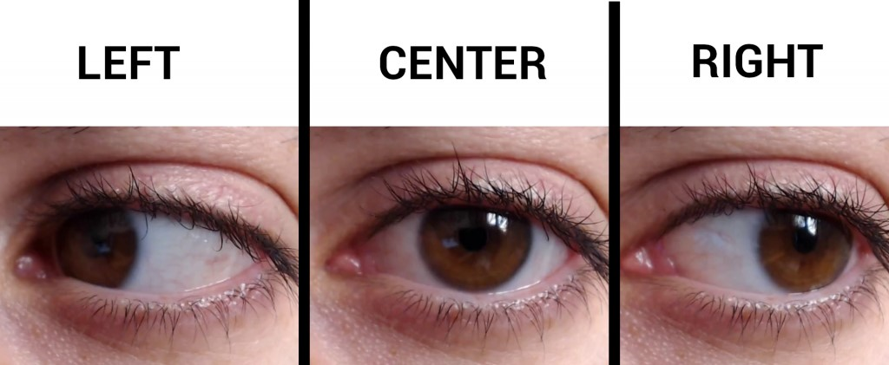

**Figure 4.5** Variation of Scleral Visibility with Gaze: Comparative image series displaying eyes at different angles, highlighting the changing visibility of the sclera, a crucial feature for understanding eye movements and gaze analysis.

If the driver is looking towards left till 45 frames, then the system gives the status as “Gazing Left” and he continues looking towards left for more than 45 frames then the system gives the status as “Distracted looking left”. Additionally, the system indicated "Gazing Right" if the driver looks to the right till 45 frames. If the driver maintains this gaze for more than 45 frames, the system indicates "Distracted looking Right."

# Results

The results of the drowsiness detection system evaluation demonstrate its performance in accurately identifying different drowsiness-related states under varying lighting conditions. The system achieved varying levels of accuracy for each specific state during both daylight and low light scenarios.

During daylight conditions, the system displayed commendable accuracy, with the "Sleeping! Wakeup" state being most accurately detected at an impressive 91.67%. Additionally, the "Drowsy" and "Drowsy! Wakeup" states exhibited robust performance, surpassing 80% accuracy. The "Eyes Closed" and "Nodding" states also displayed reasonable accuracy, achieving around 69% accuracy.

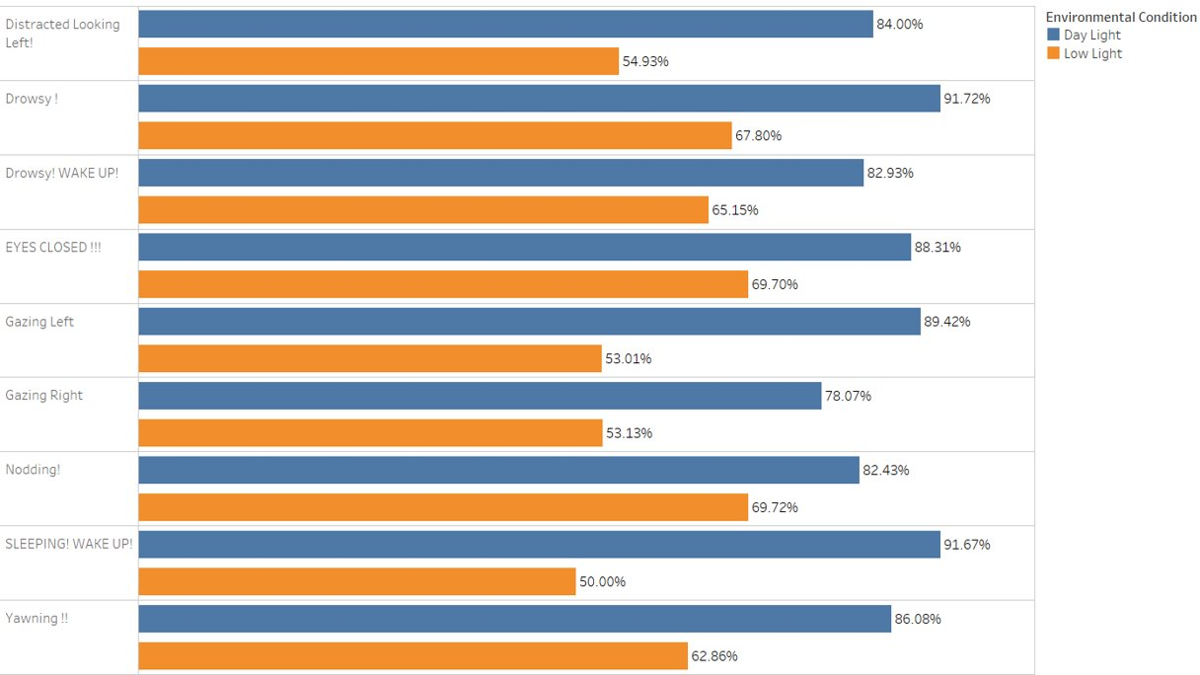

**Figure 5.1** shows accuracy of different states of drowsiness during daylight and low light.

However, the system encountered challenges in low light settings, leading to reduced accuracy across all states. The "Sleeping! Wakeup" state, which had high accuracy in daylight conditions, dropped to 50% accuracy in low light. Similarly, the accuracy of the "Gazing Left," "Gazing Right," and "Distracted Looking" states diminished significantly, with values ranging from 53% to 84% during daylight, declining further in low light.

Overall, the drowsiness detection system exhibits promising performance in daylight conditions, effectively identifying drowsiness-related states with high accuracy. Nevertheless, improvements are required to address the limitations in low light settings and to ensure the system's reliability in real-world scenarios with varying lighting conditions. Future work should focus on enhancing the system's capabilities in low light environments to improve its effectiveness and practical applicability.

# Discussion

Truck drivers’ sleepy driving is a serious problem, and the creation of a sleepiness detection system utilizing OpenCV and dlib has shown promising results. We will go through the system's main results, advantages, disadvantages, and potential future enhancements in this part.

The key feature of our system is to detect the early signs of drowsiness by calculating Eye Aspect Ratio (EAR), Mouth Aspect Ratio (MAR), Gaze Ratio and Nodding angle. There are different statuses defined for the drivers like Sleeping, Active and Drowsy, Yawning, Nodding , Gazing left, Looking Forward and Gazing Right by these parameters so far, our system can predict more than 80% in all states excluding Gazing Right where our model could provide accuracy of 78% in daytime.

The accuracy of the system was influenced by the diversity in facial features and eye behaviors displayed by different individuals during drowsiness. To enhance performance across various individuals, it would be advantageous to gather more comprehensive and diverse datasets and investigate the development of personalized models.

The system's performance may be affected under challenging lighting conditions, such as low-light or harsh sunlight, leading to reduced accuracy in drowsiness detection. There are certain limitations in our system like the camera angle must be set at a certain position, if the driver has worn sunglasses, then the system fails to detect the drowsiness. If someone wants to improve the prediction then we recommend using infra ray sensors, so the system can predict drowsiness at nighttime. Additional research and improvements are necessary to boost the system's precision and overall performance. Exploring the incorporation of diverse data modalities, such as steering behavior and vehicle speed, holds the potential to strengthen the drowsiness detection process further.

# Conclusion

The Drowsiness Detection System's effectiveness in correctly forecasting a variety of driver alertness states is demonstrated by the performance evaluation findings. The technology has the potential to improve driver safety and prevent potential accidents brought on by fatigued driving behaviors, as seen by the high accuracy levels attained across a variety of categories. The Drowsiness Detection System, an important component of contemporary vehicle safety, has enormous potential for lowering traffic accidents and enhancing all-around traffic safety.

# Future Work

Improving the performance of the sleepiness detection system in low-light environments is still a priority. Future research should look towards better image processing algorithms and sensor technologies that can record and analyze facial features even in low-light situations. To enable the system to perform properly at night or in low light situations, the integration of specialized low-light cameras or infrared sensors could be investigated. Personalizing the drowsiness detection system based on individual driving characteristics is an exciting future development topic. The system can be modified to adapt to various driver qualities, such as facial form, eye movement patterns, and other relevant attributes.

Our drowsiness detection system works with video data at a set frame rate per second (30 FPS). However, future work should focus on constructing models that can efficiently handle films with various frame rates to improve the system's versatility and application.

Standard eye recognition devices may struggle with identifying eye-related features in situations with little or no visible light. Infrared-based eye tracking devices, which can illuminate the eyes with infrared light and capture more specific eye movements and features even in complete darkness, should be investigated in the future. Integrating infrared-based eye detection can considerably improve the system's performance when driving at night or in situations when regular cameras fail to reliably capture eye movements.

# Acknowledgment

We want to express my sincere appreciation to all those who have contributed to the successful completion of the drowsiness detection system project. Their unwavering support, valuable guidance, and collaboration have been indispensable throughout this endeavor.

Above all, we extend our heartfelt thanks to the researchers and experts in the field of drowsiness detection. Their pioneering efforts and dedication have paved the way for advancements in this domain, serving as a profound inspiration for us to build upon their accomplishments and strive for excellence.

We are deeply grateful to all the team members who actively participated in this project. Their hard work, enthusiasm, and willingness to share their video data for testing were vital in ensuring the effectiveness and precision of the drowsiness detection system. Their commitment played a pivotal role in bringing this project to a successful culmination.

A special acknowledgment goes to Professor Pratik Bedi and Manjari Maheshwari for their invaluable roles in initiating and guiding this project right from its inception. Their expertise, and constant encouragement have been instrumental in shaping our approach and refining our methodologies.

We cannot thank enough Professor Umair Durrani for his exceptional contributions. His profound insights, visionary leadership, constructive feedback, and assistance in integrating additional features into the model have significantly elevated the system's capabilities and robustness. His mentorship and support have been pivotal in pushing the boundaries of our work.

# References

1. Azim, Tayyaba, et al. “Fully Automated Real Time Fatigue Detection of Drivers through Fuzzy Expert Systems - ScienceDirect.” ScienceDirect.Com | Science, Health and Medical Journals, Full Text Articles and Books., 25 Jan. 2014, <https://www.sciencedirect.com/science/article/abs/pii/S1568494614000398>.
2. Albadawi, Y., AlRedhaei, A., & Takruri, M. (2023, April 29). *Real-time machine learning-based driver drowsiness detection using visual features*. MDPI. [https://www.mdpi.com/2313-433X/9/5/91](https://www.mdpi.com/2313-433X/9/5/91%20)
3. Akrout, B., & Fakhfakh, S. (2023, February 15). *How to prevent drivers before their sleepiness using deep learning-based approach*. MDPI. [https://www.mdpi.com/2079-9292/12/4/965](https://www.mdpi.com/2079-9292/12/4/965%20)